Analyst Name: Tanvi Sachin Itagikar
Date of Investigation: April 25, 2026
Project Goal: To perform a professional security audit on an API to identify vulnerabilities.

1. Introduction & Methodology
Modern SaaS applications rely heavily on APIs to communicate between the front-end and back-end. In this audit, I performed a Security Risk Analysis on the ReqRes API endpoints.
The audit focused on identifying vulnerabilities mentioned in the OWASP API Security Top 10, specifically:
- Broken Authentication
- Improper Error Handling
- Information Disclosure
Tools Used:
- Postman: For sending manual HTTP requests and inspecting payloads.
- JSON Analysis: Evaluating the structure of the data returned by the server.

2. Detailed Findings & Risk Assessment
Finding #1: Improper Error Handling & "Verbose" Responses
- Vulnerability Type: Information Disclosure via Detailed Error Messages.
- Analysis: During testing, a request was sent to the endpoint without an API key. Instead of a standard "401 Access Denied" message, the API responded with a detailed guide on how to fix the error. It revealed:
  - The exact header name required: x-api-key.
  - The alternative authentication method: Authorization: Bearer <session_token>.
  - A "Hint" directing the user to a specific URL for key generation.
- Risk Severity: High (Medium-High)
- Business Impact: Detailed error messages reduce the "cost of attack" for a hacker. By revealing the exact headers and token types used, an attacker can bypass the initial discovery phase and move straight to brute-forcing or credential stuffing.
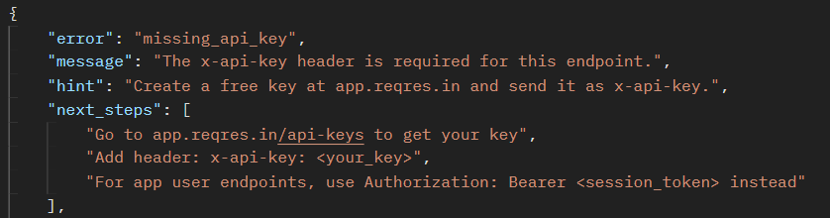
Finding #2: Metadata Exposure (Internal System Mapping)
- Vulnerability Type: Information Leakage in Metadata.
- Analysis: The API response includes a _meta object. This section leaks:
  - System versioning: variant: v1_a.
  - Internal documentation URLs: https://app.reqres.in/documentation.
  - Example application links: notes-app examples.
- Risk Severity: Low
- Business Impact: While not directly exploitable, this helps in Reconnaissance. If a vulnerability is ever discovered in v1_a, an attacker will immediately know this system is vulnerable. It exposes the internal file structure and naming conventions of the company.
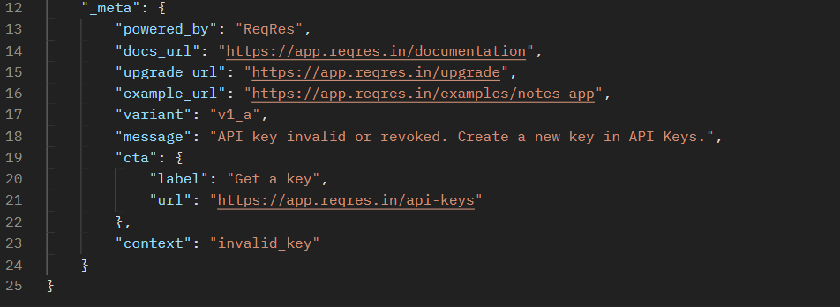

Finding #3: Lack of Authorization for Public Endpoints
- Vulnerability Type: Improper Assets Management.
- Analysis: While some endpoints require a key, many user-data endpoints allow anyone to fetch lists of users without any login. This is a common risk where "Public" and "Private" data are not clearly separated.
- Risk Severity: Medium
- Business Impact: Competitors or malicious actors can "scrape" the entire user database of a SaaS platform, leading to data privacy concerns and loss of intellectual property.

3. Risk Comparison Table
Risk ID | Vulnerability Name | Severity | Status | OWASP Category
API-001 | Verbose Error Messages | Medium | Open | API7:2023 - Server Misconfiguration
API-002 | Metadata Exposure | Low | Open | API7:2023 - Information Disclosure
API-003 | Excessive Information | Medium | Open | API3:2023 - Data Leakage

4. Strategic Remediation Suggestions (Business Recommendations)
To secure the SaaS infrastructure, I recommend the following professional fixes:
A. Implement "Silence on Failure" Policy
The API should not "help" the user when they fail to authenticate.
- Fix: Remove the hint, next_steps, and example_curl fields from production error responses.
- Outcome: Attackers will not know what headers or tokens the system expects.
B. API Gateway & Rate Limiting
Deploy an API Gateway (like Kong or AWS API Gateway).
- Fix: Set a limit of 100 requests per minute per API Key.
- Outcome: Protects the system from automated bots and DoS (Denial of Service) attacks.
C. Use Standard HTTP Status Codes
- Fix: Instead of a custom JSON error, use standard codes:
  - 401 Unauthorized for missing keys.
  - 403 Forbidden for wrong permissions.
  - 404 Not Found for invalid endpoints.
D. Data Masking
- Fix: Ensure that sensitive metadata (like version numbers or internal links) is stripped out from the response body before it leaves the server.

5. Conclusion
The ReqRes API is functional but prioritizes "Developer Ease of Use" over "Security." In a production SaaS environment, the detailed hints provided by the API pose a significant security risk by making it easier for unauthorized actors to understand the authentication flow. Implementing the suggested remediation steps will significantly harden the API against modern cyber threats.

